Kenwood General

# Geoff Anderson G3NPA

## 1.0 CAT CONNECTION TYPES

There are three types of connections for using CAT with Kenwood radios.

Note: DTR/RTS setting in Radio setup table.

You may need to check either of “Set DTR high” or “Set RTS high” option. It depends on your radio and CAT interface.

## 1 Type A

You need IC-10 kit installed in radio plus an external IF-232C interface box. A 6-pin DIN cable is required between the radio and the IF-232C, and a standard RS-232C cable is connected between the IF-232C interface box and the PC’s serial port.

Example radios: TS-440, TS-850, TS-940, etc.

## 1.2 Type B

Radio has RS-232C port. A standard RS-232C cable is connected between the radio’s RS-232C port and the PC’s serial port.

Example radios: TS-480, TS-570, etc.

### 1.3 Type C

Radio has both RS-232C port and USB port. You may use either of them.

To use the radio’s RS-232C port, connect a standard RS-232C cable between the radio’s RS-232C port and the PC’s serial port.

To use the radio’s USB port, connect a USB cable between radio’s USB port and the PC’s USB port. You must install a USB driver correctly.

Example radios: TS-590S, TS-590SG, TS-990 etc

**Note** for Type A and Type B radios (no USB port): If your PC has USB ports but no RS-232 ports, you will need a serial-to-USB adapter in line with your RS-232 cable. Users of many different logging programs have reported difficulties when using an adapter based on anything other than a genuine FTDI chip. The latest driver for your specific operating system can be found at [www.FTDIchip.com](http://www.FTDIchip.com) or obtained from the manufacturer of your adapter.

**2.0 BASIC CAT COMMAND PROTOCOL**

All Kenwoods use the same basic CAT command protocol; however, the available commands for a specific model may be expanded beyond the basic set. (A good example can be found in the added commands for the sub-receiver of the TS-950 series.) For details, check the CAT command programmer’s reference manual for your specific radio.

The Kenwood protocol is also used by Elecraft and in the latest Yaesu radios.

## 2.1 Some Basic Command Examples:

**Request**

IF;

**Reply**

Ifxxx....xxx; xxx is 35 byte data. It shows radio’s frequency, mode etc.

**Request**

FA;

**Reply**

FAxxx....xxx; xxx is 11 byte data. It shows radio’s VFO A frequency.

**Request**

MD;

**Reply**

MDx; x is 1 byte data. It shows radio’s mode parameter. 1=LSB, 2=USB, 3=CW etc

**Note:** There may be some differences in data structure for each radio.

**3.0 TF-SET CONTROL**

You can use $TF-Set$ and $mouseTF-Set$ macro in Radio Control Panel, CW Machine and Soundcard Data Window for following Kenwood Radios.If $mouseTF-Set$ macro is defined in a function key then this function key works just like TF-SET button on radio’s panel.

TS-590

TS-990

You need to check corresponding option in Setup Radio table to enable this function.

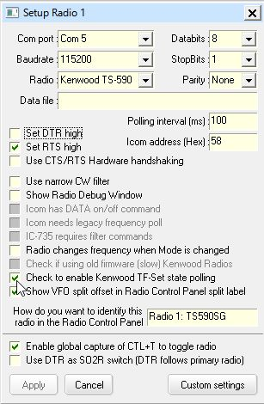

KG_1